“Measuring Air Quality and Meteorological Parameters” Practical

1) Aims of this exercise
• To become familiar with the different types and sources of error associated with atmospheric measurement data
• To apply this knowledge to conduct a simple statistical and error analysis on measured atmospheric data.

2) Background

- a. Error Analysis

It is essential to take errors into account when using and interpreting atmospheric measurements. There are three main types of such errors (or uncertainties):

- 1) Systematic error
- These are consistent, repeatable errors associated with a measurement “bias” in the instrument we are using or a flaw in the design of the experiment.
- They are usually caused by improper instrument calibration or instrument sensitivity to some other variable, such as temperature or humidity (e.g. where a change in temperature affects the accuracy of another measurement such as the concentration of a gas).

- 2) Random error (or “non-systematic error”)
- These are unpredictable errors (but they can be quantified by repeated measurements). They are typically referred to as “noise” and usually have a Gaussian distribution around some mean. This means it is possible to quantify the error as a standard deviation by examining the distribution of many separate measurements (usually >100 to ensure a meaningful statistical representation). An example of this pattern is shown below. Noise errors are typically Gaussian and can be quantified by repeated measurements.

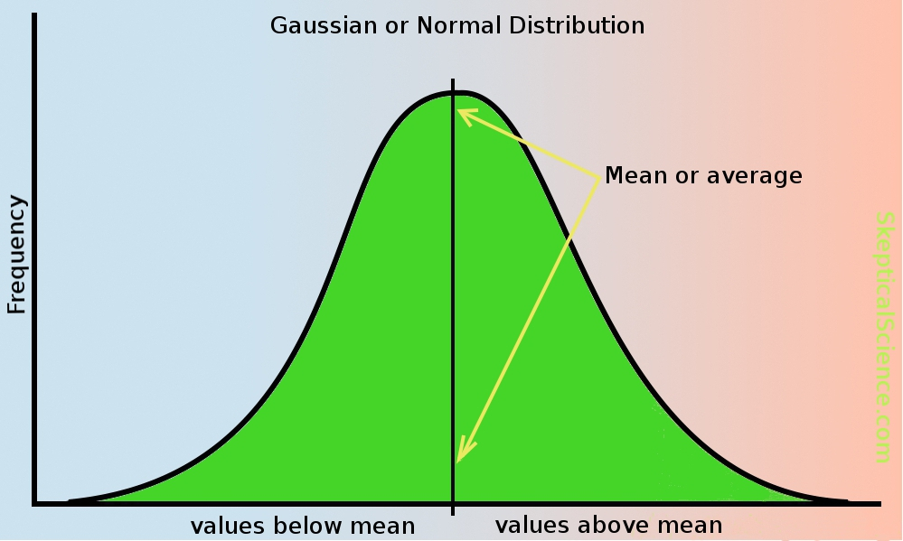

- Representativity error
- These are associated with some flaw in the design of a survey that means that some assumptions about what we might be measuring become invalid. For example, if we measure the temperature half-way up a mountain, is it the same at the top? How representative of the surrounding area is our measurement?

However, another source of error that must be taken into account is human error. For example, measurements need to be checked diligently and we need to make sure that maximum care is taken when logging the data (both in notebooks and when entering them on a computer). For example, if we measure relative humidity with an instrument when we are breathing near it, this may invalidate the data because we would be measuring the humidity of our breath and not the atmosphere! It can be hard to quantify these errors but we should bear them in mind when we interpret the results. For example, if we want to know the temperature at the top of a mountain but we can only get half way up, what can we say about the confidence we have when interpreting the data (e.g. would we expect this to be an under-estimate? And if so, why?).

b. Air Quality and Meteorology
Air quality in large urban areas like Manchester is not only affected by the emissions coming from things like vehicles and industry. The meteorology in these areas can affect how long these air pollutants stay around for in the air, and how they are dispersed in and around the surrounding area. We need to be aware of these effects and how they may affect the representivity of our measured data.

3) The Practical: Preparation Information & Experiment Details

Practical preparation and advice
- You should work individually when answering the questions in the online test (on Blackboard)– you should not work as a group.

- Your Kestrel handheld weather stations will be given to you at the start of the practical, and your group will be given a letter as an identifier (A to F) The letter will correspond to the location on a map, from which you will take your measurements.

- During the practical, make sure that your Kestrel and phone are kept in close proximity to each other (within 5 m). If not, Bluetooth connectivity may be lost and you may lose your data.

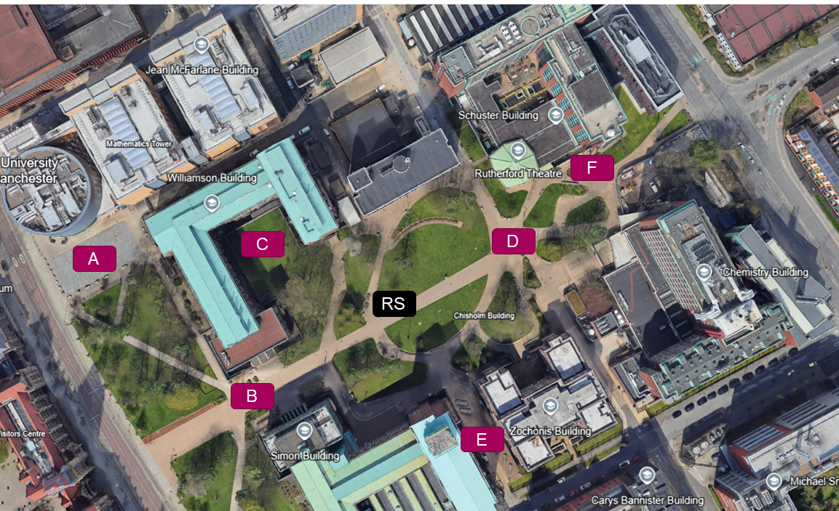

Experiment 1 – Representativity Error

  - Each group should go to your group measurement location in Brunswick Park. Before the practical starts, you will have some time to get familiar with your Kestrel instrument and to make some notes about the surrounding conditions such as:
  - Is your Kestrel connected to your Kestrel LiNK app? (The app should have been installed onto your phone before the practical.)
  - Are there any buildings or trees nearby?
  - What is the weather like today?
  - Can you establish where the wind is coming from? (see below for some advice about this)

Everyone will take measurements in your location for 15 minutes. The Kestrels have been configured to automatically log the meteorological data every 5 seconds. However, as scientists, we can’t always rely on our instruments working. Fieldwork is all about making notes – recording our data manually is advisable, should our instruments not work properly. Therefore, during the practical, you will also manually record pressure, temperature, relative humidity, wind speed and wind direction every 2 minutes.

How to view the meteorological data when manually recording your measurements (if the app is not receiving data)
- Use the UP/DOWN arrow buttons on the Kestrel to navigate between your measured pressure, temperature, relative humidity, wind speed and wind directions.

- Tips and advice for taking wind measurements
1. Make sure you expose the impeller (the small propellor at the top of your Kestrel) to the wind by removing the plastic cover – see below:

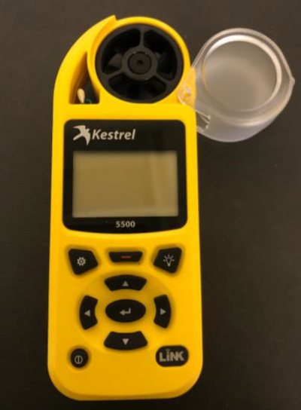

2. When taking wind direction measurements:
You need to hold the Kestrel pointing straight into the wind. It might not always come from exactly the same direction, in which case you need to find your “best guess” of where the wind is coming from. To do this you could:
- pick a blade of grass or a leaf, let go of it and see which way it goes
- hold up something like a scarf or piece of string
- look at nearby plants or trees as a guide

Once you’ve established an approximate direction, how does it compare to the surrounding buildings? Make a note of that. For example, “the wind was at 45 degrees to Road X or Path Y”.

  - Later you can then look at a map to work out the compass direction that the wind was coming from.
  - Note: the wind direction is generally noted as where the wind is coming from. This is because when you are looking at weather and air pollution, you tend to be more interested in where the pollution or air mass is coming from.

Experiment 2 – Systematic Error

During the activity, there will be a standard high-precision reference weather station, which will be situated in Brunswick Park. You will be shown the location of the weather station as the practical starts.

The weather station will be taking meteorological measurements at the same time as you are taking yours at a different location. You will calculate the offset (i.e. the systematic error) by subtracting your measured mean temperature, pressure and relative humidity from the corresponding means calculated from the reference weather station data. Subtracting the difference of these two values from your measured data will calibrate your measurements to those of the high-precision instrument. This is a very common way to remove bias error from scientific measurements. The reference weather station data will be made available for you on Blackboard after the activity.

At the end of the practical
- Export the data logged to your phone using the “Kestrel LiNK” app on your phone (see “Connecting and configuring the “Kestrel LiNK” app” resources on Blackboard for how to do this). You can email the Kestrel data file to yourself form your phone.
- Make sure to turn your Kestrel off at the end of the practical
- Return your Kestrel to staff.

4) Assignment and online test

Each individual will complete an online test to answer questions about data calculated from the measurements collected by one of the Kestrel weather stations and the reference weather station.

Preparing your data for analysis

  - - When you export your measured data and open it in Excel, you will see a table containing all of the meteorological data that your Kestrel has logged during the practical. You will only need the following columns:

  - Date-Time, Temperature, Relative Humidity & Barometric Pressure

  - - Please enter your group’s calibrated data (including the calibration offsets that you applied) into the measurement entry spreadsheet on Blackboard and ensure that this is sent to dogushan.kilic@manchester.ac.uk by the deadline listed on Blackboard.

  - - Dogushan will then merge all the data into one spreadsheet and make this available to you on Blackboard for your analysis for the online test.

  - The online test mark will not count towards your degree mark. It is a learning exercise. You will receive instant feedback on your answers with some guidance on what the correct answer is and how to calculate it. You can repeat the test as many times as you like.

  - Further guidance on how to answer the questions is provided in the Assignment Information and help sheets tab on Blackboard.

